Standard Operating Procedure (SOP) #16

Managing Photographic Images

Version 2.01 (May 24, 2021)

Change History

|  |  |  |  |  |  |
| --- | --- | --- | --- | --- | --- |
| New Version # | Revision Date | Author | Changes Made | Reason for Change | Previous Version # |
| 2.0 | 5/24/2021 | Kelly Kozar, Kim Weisenborn, Jacob Gross | Updated folder structure and instructions. Revised section on organizing images, and few other minor updates like SOP references and external links. Added new procedures for managing photos captured with ArcCollector app, utilizing AGOL cloud storage, and photo processing with ArcGIS and R. | To reflect current folder setup and how to process the images. To update outdated SOP references and external links. To better document species identifications and utilize the suite of capabilities available with smart devices, ESRI apps, and AGOL. | 1.0 |
| 2.01 | 3/17/2022 | Kim Weisenborn |  |  | 2.0 |
|  |  |  |  |  |  |

Only changes in this specific SOP will be logged here. Version numbers increase incrementally by hundredths (e.g., version 1.01, version 1.02) for minor changes. Major revisions should be designated with the next whole number (e.g., version 2.0, 3.0, 4.0). Record the previous version number, date of revision, author of the revision, changes made, and reason for the change along with the new version number.

Purpose

This SOP describes how to download and process ArcCollector® photographic images collected by project staff or volunteers during the course of conducting Focal Terrestrial Plant Communities (FTPC) and Established Invasive Plant Species (EIPS) monitoring. For steps on collecting ArcCollector photos see SOP #8 Using Collector for ArcGIS. Images that are acquired by other means—e.g., downloaded from a website or those taken by a cooperating researcher—are not project records and should be handled separately.

Three specific ArcGIS Online (AGOL) layers are used to distinguish the three types of vegetation monitoring photos collected in the field:

1. FTPC Point Photos
2. EIPS Point Photos
3. FTPC & EIPS Plant Photos

Each of the three types of photos above are taken using the ESRI® ArcCollector App. Other miscellaneous photographs (not taken with ArcCollector) that are pertinent to the monitoring season can be stored in the vital signs ‘Misc’ folder:

* *I:\vital_signs\05_focal_terr_plant_communities\Images\2021\HAVO\Misc*
* *I:\vital_signs\12_established_invasive_plant_species\Images\2021\HAVO\Misc*

Image Management Workflow

Effectively managing hundreds of photographic images requires a consistent method for downloading, naming, editing, and documenting. The general process for managing photos proceeds as follows:

1. File structure setup
2. Image acquisition
3. Syncing & Downloading files
4. Process Photos
5. Rename the image files according to convention
6. Review and edit or delete the photos
7. Move into appropriate folders for storage
8. Establish database links
9. Document the photos
10. Final storage

File Structure Setup

Prior to data collection for any given year, project staff will need to set up new folders under the “Images” folder in the FTPC & EIPS monitoring project workspace. Folder structures should be set up as follows (see Figure SOP 16.1 and 16.2):

Images*I:\vital_signs\05_focal_terr_plant_communities\Images* (FTPC) -or-

*I:\vital_signs\**12_established_invasive_plant_species\Images* (EIPS)

[Year] The appropriate year (e.g., 2020, 2021, etc.)

_attributes Attributes of the photo that are populated in the field when the photo is taken.

[PARK] Arrange files by 4-letter park code (e.g., HAVO, HALE, etc.)

Data Organized and watermarked plot photos arranged by sampling location and date.

Misc Non-ArcCollector photos that may be pertinent to the monitoring season.

Originals Raw photos exported from AGOL file geodatabase.

Plant_photos Organized and watermarked plant photos arranged by sampling location and date.

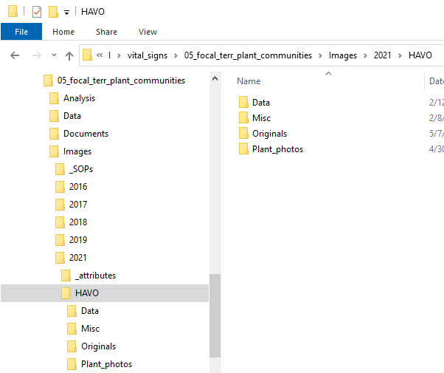

**Figure SOP 16.1.** Example of FTPC Images subfolder structure for current project year and park.

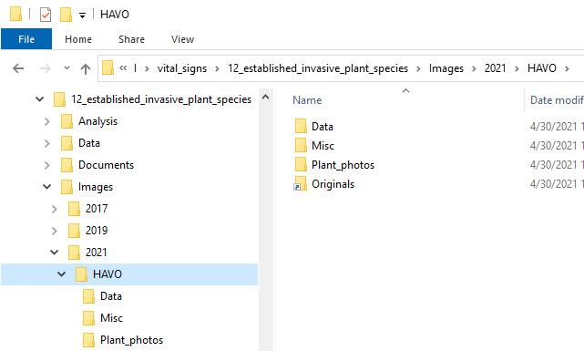

**Figure SOP 16.2.** Example of EIPS Images subfolder structure for current project year and park.

This folder structure permits data images to be stored and managed separately from miscellaneous images collected during the course of the project. It also provides separate space for storage of originals. For additional information about the project workspace, refer to SOP #14 Workspace Setup and Project Records Management.

Image Acquisition

For steps on collecting ArcCollector photos, see SOP #8 Using Collector for ArcGIS.

Syncing & Download Images

Syncing

During field collection, ArcCollector photos and corresponding attribute information are stored locally on the mobile device and must be uploaded (synced) to ArcGIS Online once back in a connected environment. See SOP #8 Using Collector for ArcGIS for steps to complete data synchronization/upload.

Downloading

Weekly downloads from AGOL to the I:\ drive should also be performed to back-up the images and attributes stored on the AGOL cloud server.

To download images and data from AGOL:

1. Navigate to AGOL at <https://nps.maps.arcgis.com/>, and click “Sign In” in the top right-hand corner. If you need help logging into AGOL, contact the PACN GIS Specialist.



1. The ESRI sign in page will open. Click the “National Park Service” button to complete the log in process.

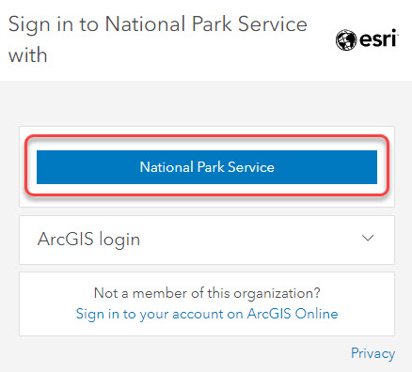

1. Navigate to Groups by clicking “Groups” from the upper-left navigation bar.



1. Under My Groups, click on the “PACN Vegetation” group. You must be added to this group in order the access. If you are having trouble accessing the group, contact the PACN GIS Specialist.



1. Click on the appropriate layer: FTPC Photos, EIPS Photos, or Plant Photos (note all three layer files will need to be downloaded separately). You may need to click on “View all group content”.

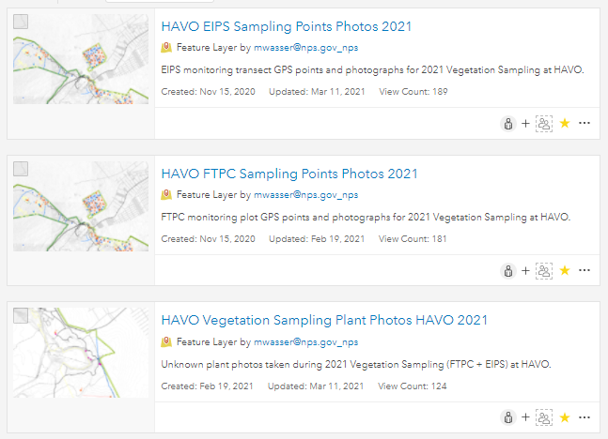

1. Export the data from the layer to a file geodatabase (FGDB) by clicking on the “Export Data” drop-down à “Export to FGDB”.

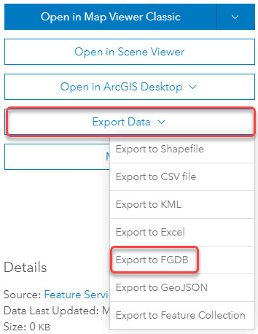

* 1. An Export to File Geodatabase prompt will open:
     1. Update the existing *Title* field to “ftpc” “eips” or “plants” (respectively) followed by and underscore (_) and the sampling event date “YYYYMMDD” [1] (e.g., plants_20210507, eips_20201003, ftpc_20200829).
     2. Under the Tags section, type in a tag that correlates with the respective layer (e.g., “ftpc”, “eips”, or “plants”) and hit the *Enter* key to add a tag.
     3. Click “Export”.

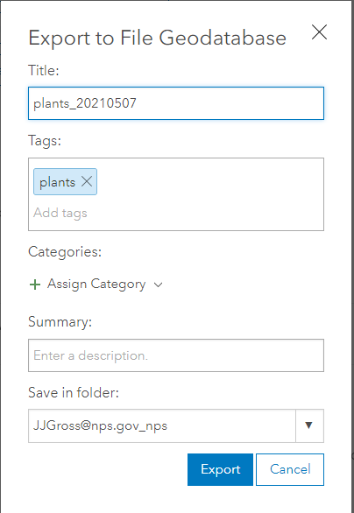

1. Click “Download” to complete the export process.

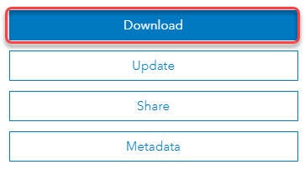

1. **Save as** to the vital_signs “Spatial_info” folder for the appropriate year and park:

* FTPC – *I:\vital_signs\05_focal_terr_plant_communities\Spatial_info* à Year folder à Park folder à “GIS_Data” à “Data” à “AGOL_Exports”
* EIPS – *I:\vital_signs\12_established_invasive_plant_species\Spatial_info* à Year folder à Park folder à “GIS_Data” à “Data” à “AGOL_Exports”

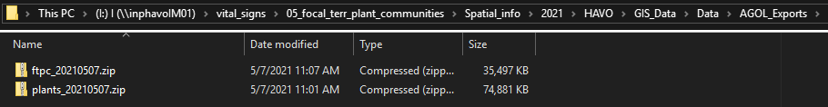

Alternatively, instead of downloading images directly from AGOL, an easier option may be to use ArcGIS Pro®, connect to the AGOL account, and export the appropriate geodatabase layer directly from ArcGIS Pro. For steps on this process, contact the PACN Botanist or Lead Plant Biological Science Technician for assistance.

Process ArcCollector Images

Use the following steps to process ArcCollector images, add watermarks to photos, organize the photo with the correct folder structure, and name the photos.

1. Using ArcGIS Pro, open the file geodatabase (.gdb) found in the “Spatial_info” folder for the appropriate year and park (see folder locations below), or download the latest version of the layer file to a file geodatabase from AGOL if needed.

* FTPC – *I:\vital_signs\05_focal_terr_plant_communities\Spatial_info* à Year folder à Park folder à “GIS_Data” à “Data” à “AGOL_Exports”
* EIPS – *I:\vital_signs\12_established_invasive_plant_species\Spatial_info* à Year folder à Park folder à “GIS_Data” à “Data” à “AGOL_Exports”

1. Open the python script (Export Attachments.py) found in the Attachments toolbox (Attachments.tbx) on the I:\ drive:

* FTPC – *I:\vital_signs\05_focal_terr_plant_communities\Images\process_images\ArcGIS_Toolbox* (there is a shortcut to this folder in *I:\vital_signs\12_established_invasive_plant_species\Images*)
  1. Here is the raw python script for reference only.

import arcpy

class ToolValidator(object):

"""Class for validating a tool's parameter values and controlling

the behavior of the tool's dialog."""

def __init__(self):

"""Setup arcpy and the list of tool parameters."""

self.params = arcpy.GetParameterInfo()

def initializeParameters(self):

"""Refine the properties of a tool's parameters. This method is

called when the tool is opened."""

return

def updateParameters(self):

"""Modify the values and properties of parameters before internal

validation is performed. This method is called whenever a parameter

has been changed."""

return

def updateMessages(self):

"""Modify the messages created by internal validation for each tool

parameter. This method is called after internal validation."""

return

1. Run the “Export Attachments” script using the following inputs:
   1. Attachments Table = “*geodatabase name*__ATTACH”
      1. This is the table within the file geodatabase that contains the photos.
   2. Attachments Folder =   
      FTPC – *I:\vital_signs\05_focal_terr_plant_communities\Images* à Year folder à Park folder à “Originals” à “ftpc_photo_export”  
        
      EIPS – *I:\vital_signs\12_established_invasive_plant_species\Images* à Year folder à Park folder à “Originals” à “eips_photo_export”  
        
      Plants - *I:\vital_signs\05_focal_terr_plant_communities\Images* à Year folder à Park folder à “Originals” à “plant_photo_export” (plant photos will be later separated out between EIPS and FTPC after processing is complete)
      1. This is where the exported photos will be saved.
   3. Click “OK”

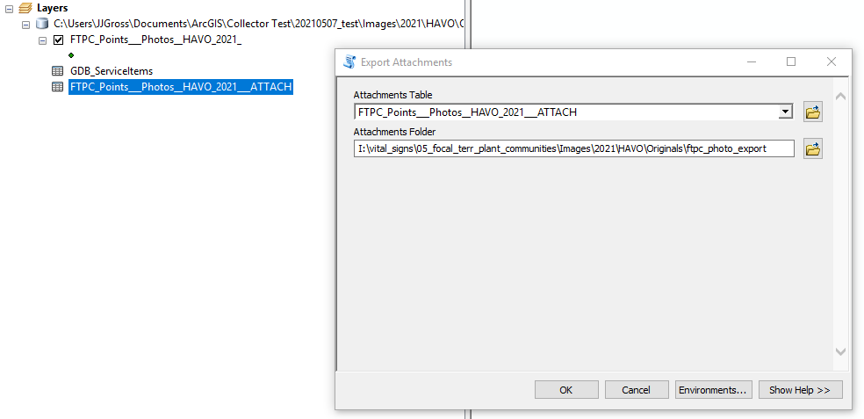

1. Right-click on the respective “…__ATTACH” table and select “Joins and Relates” > “Join …”

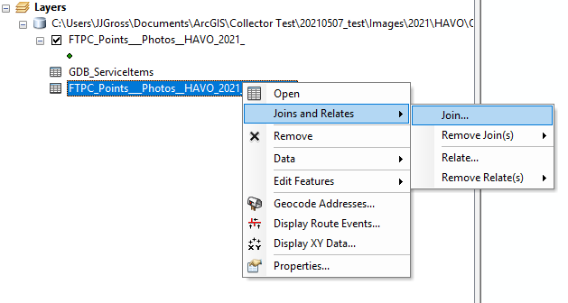

* 1. For field the join will be based on select “REL_GLOBALID”
  2. For Table to join to this layer select the point dataset (example: “FTPC_Points__Photos__HAVO_2021_”)
  3. For field in table to base the join on select “GlobalID”
  4. Join Options = Keep all records
  5. Click “OK”

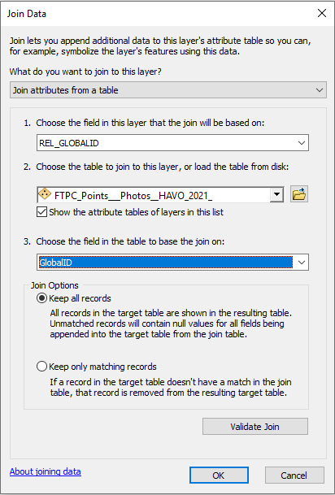

Each photo in the table now has attribute data joined to it.

1. Export the joined attributes table by right-clicking on the table and selecting “Data” > “Export…”

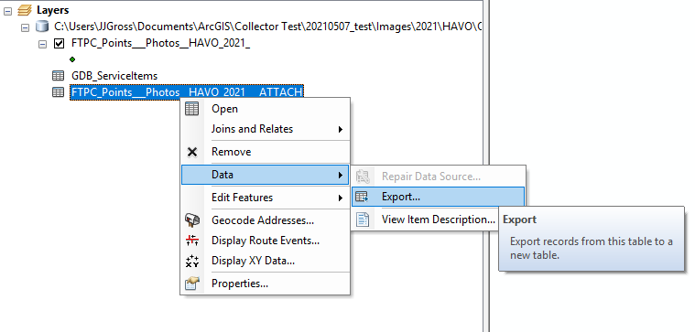

* 1. Make sure “All records” are selected for Export.
  2. Save the output table in folder where the photos were exported in the “Originals” folder.
  3. Make sure “Text File” is set for the “Save as type” by clicking the  icon.

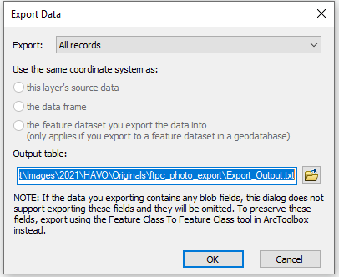

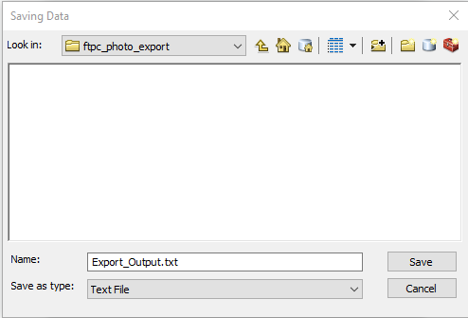

* 1. Click “Save”, then Click “OK”
  2. You do not need to add the table to the map.
  3. Save the .mxd if desired and close ArcGIS

1. Copy and paste the “process_images_YYYYMMDD.R” file into the same folder where the photos and the joined attributes table were exported.
   1. .R script file can be found here:  
      FTPC – *I:\vital_signs\05_focal_terr_plant_communities\Images\process_images* (there is a shortcut to this folder in *I:\vital_signs\12_established_invasive_plant_species\Images*)
      1. Paste into folder where photos and table were exported:  
         FTPC – *I:\vital_signs\05_focal_terr_plant_communities\Images* à Year folder à Park folder à “Originals” à “ftpc_photo_export”  
           
         EIPS – *I:\vital_signs\12_established_invasive_plant_species\Images* à Year folder à Park folder à “Originals” à “eips_photo_export”  
           
         Plants – *I:\vital_signs\05_focal_terr_plant_communities\Images* à Year folder à Park folder à “Originals” à “plants_photo_export”
2. Open the R script **“process_images_YYYYMMDD.R”** and press Ctrl + Alt + R to run the script.
   1. Files will automatically be watermarked, renamed, and copied to the correct folder structure.

The Photo Record datasheet (Figure SOP 16.3) is used as a checklist to ensure all required photos are taken in the field. The datasheet can also be used as a backup photo organization method if Collector is unavailable. For example, if a standard camera is used, the photo image filename (or date and time) can be recorded for each image to allow future linking of attribute data. If there is no image of this datasheet you will have to check the hardcopy datasheets or the scanned datasheets in *I:\vital_signs\05_focal_terr_plant_communities\Data\Scanned_Datasheets* or *I:\vital_signs\12_established_invasive_plant_species \Data\Scanned_Datasheets*.

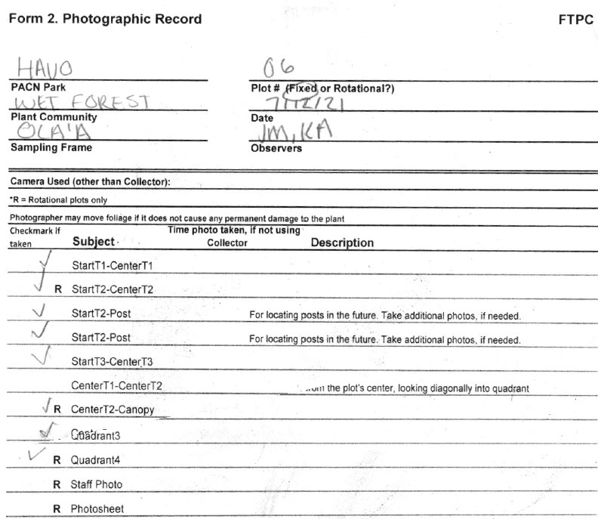

**Figure SOP 16.3**. Example of a Photo Record datasheet.

Folder & File Naming Standards

In all cases, folder & file names should follow these guidelines:

* No spaces or special characters in the folder name
* Use the underscore (“_”) character to separate words in folder names
* Try to limit length of names whenever possible
* Dates within folder names should be formatted as YYYYMMDD[2] for better sorting

Within the “Data” and “Originals” folders, plot folders should be created for each sampling event in which sampling is being conducted for the field season. Individual plot folders should be named to distinguish between protocol, sampling frame, plot type and number, and date that the plot was sampled. If a sampling event is multiple days long, use the first date of the sampling event in the folder naming structure.

Collector images will be renamed using the “process_images_YYYYMMDD.R” script and will adhere to the file naming conventions below.

**Folders:** (See Table SOP 16.1)

[Protocol]_[Community]_[Sampling_Frame]_[Plot_Type+Plot_Number]_[Date]

Example ‘FTPC_W_OL_F10_20210517’

Example ‘EIPS_W_KU_R38_20110604’

Example ‘EIPS_S_MA_F01_20210817’

| Sampling Frame | Abbreviation |
| --- | --- |
| ʻŌlaʻa | OL |
| Nāhuku /East Rift | ER |
| Mauna Loa | ML |
| Kahuku | KU |
| Kaloko-Honokōhau | KH |
| Kīpahulu District | KD |
| Haleakalā | HA |
| Puʻu Aliʻi | PA |
| Kalawao | KA |
| Hoʻolehua | HO |
| Tutuila | TU |
| Ta‘ū | TA |
| Guam | GU |
| Puerto Rico | PR |

**Table SOP 16.1** Folder naming convention guide

**File**s: (See Table SOP 16.2 and 16.3)

Plot/Transect Photos: [Date]_[Plot_Type+Plot_Number]_[Subject]_[### if multiples]

Example: 20210517_R52_StartT1_CenterT1_002.jpg

|  |
| --- |
| FTPC Subject |
| StartT1_CenterT1 |
| StartT2_CenterT2 |
| StartT3_ CenterT3 |
| StartT2_Post |
| CenterT1_CenterT2 |
| CenterT2_Canopy |
| CenterT3_CenterT2 |
| EndT1_CenterT1 |
| EndT2_CenterT2 |
| EndT3_CenterT3 |
| EndT2_Post |
| Quadrant1 |
| Quadrant2 |
| Quadrant3 |
| Quadrant4 |
| Staff_Photo |
| Photo_Record |
| Other |

**Table SOP 16.2** File naming guide for FTPC photos.

| EIPS Subject |
| --- |
| 0m_End |
| 0m_Start |
| 0m_Post |
| … |
| 1000m_End |
| 1000m_Start |
| 1000m_Post |
| Staff |
| Other |
| Photorec |

**Table SOP 16.3** File naming guide for EIPS photos.

Plant Photos: [YYYYMMDD]_[XXhXXmXXs]_[Species Code]_[### if multiples]

Example: “20210226_21h01m49s_EREVAL_006.jpg”

Review Images

Delete any poor-quality photos, repeats, blurred or otherwise unnecessary photos. Low quality photos might be retained if the subject is highly unique, or the photo is an irreplaceable data photo.

Organize Images

Once images have been renamed and reviewed:

* Data images can be copied to the “Data” folder within the appropriate year and park folders:
  + FTPC – *I:\vital_signs\05_focal_terr_plant_communities\Images* à Year folder à Park folder à “Data”
  + EIPS – *I:\vital_signs\12_established_invasive_plant_species\Images* àYear folder à Park folder à “Data”
* Specimen plant photos can be moved to the “Plant_photos” folder within the appropriate year and park folders:
  + FTPC – *I:\vital_signs\05_focal_terr_plant_communities\Images* à Year folder à Park folder à “Plant_photos”
  + EIPS – *I:\vital_signs\12_established_invasive_plant_species\Images* àYear folder à Park folder à “Plant_photos”
* Any other miscellaneous images should be moved to the “Misc” folder within the appropriate year and park folders:
  + FTPC – *I:\vital_signs\05_focal_terr_plant_communities\Images* à Year folder à Park folder à “Misc”
  + EIPS – *I:\vital_signs\12_established_invasive_plant_species\Images* àYear folder à Park folder à “Misc”
* Images that are to be linked to the database will need to go into the “Database_images” folder. Copy plot folders to the appropriate year and park folders within the “Database_images” folder, and then delete any images that will not be linked to the database.
  + FTPC –*I:\vital_signs\05_focal_terr_plant_communities\Data\Database\Database_images*
  + EIPS – *I:\vital_signs\12_established_invasive_plant_species\Data\Database\Database_images*

Establish Database Links

Images for the FTPC and EIPS monitoring protocol can be directly linked to the data in the database. During data entry and processing, the database application will provide the functionality required to establish a link between each database record and the appropriate image file(s). To establish the link, the database prompts the user to indicate the root project workspace directory path, the specific image folder within the project workspace, and the specific file name. This way, the entire workspace may be later moved to a different directory (i.e., the PACN Digital Library) and the links will still be valid after changing only the root path. Refer to SOP #14 Workspace Setup and Project Records Management, and SOP #17 Data Entry and Verification for additional details on setting up the database images structure and establishing these links.

**Note:** It is important that the files keep the same name and relative organization once these database links have been established. Users should not rename or reorganize the directory structure for linked image files without first consulting with the PACN Data Manager.

The procedures for linking images to the FTPC Monitoring Database can be found in *Focal Terrestrial Plant Communities Monitoring Database User Guide*, located at *I:\vital_signs\05_focal_terr_plant_communities\Data\Database\Database_documentation*, *focal_terr_plants_database_user_guide_sql.doc.*

The procedures for linking images to the EIPS Monitoring Database can be found in *Established Invasive Plant Species Monitoring Database User Guide*, located at *I:\vital_signs\12_established_invasive_plant_species\Data\Database\Database_documentation*, *established_invasives_database_user_guide.doc.*

**Image Documentation and Cataloging**

Non-data images stored in the PACN Digital Library should be documented and cataloged. Documentation, or metadata, provides the minimum information a user will need to appropriately use the photo. Cataloging provides a collective means for searching, finding, and retrieving photos. A variety of software is available to facilitate this process; the software the PACN uses is the latest version of ThumbsPlus®. The standard operation procedure for using ThumbsPlus® gives detailed instructions on how to use the metadata database.

The NPS has published the Digital Photo Metadata Standard for all images. This standard identifies the full scope of metadata elements that a project in the NPS might use to describe, manage, and preserve digital images. The Digital Photo Metadata Standard specifies that seven metadata elements are considered mandatory. It was determined that these are the minimum number of elements required to enable an NPS project to access, interpret, and manage an image. All photos should be documented with these minimal metadata attributes:

* Date/Time
* Title
* Location
* Park Code
* Metadata/Access Control
* Constraints Information
* Contact Information

Projects should store data photo metadata attributes in the appropriate relational tables of the project database. Project databases should contain at least the minimum metadata requirements listed above.

Final Storage

At the end of the season, and once the year’s data are certified, data images for the year will be moved to the PACN Digital Library for archival. Before data is certified all data images should be checked for completeness and linked to the database. Since the project images are on the network server, simply inform the PACN Data Manager that the images are ready to be archived. These files will be loaded into the FTPC/EIPS monitoring project section of the PACN Digital Library, and the database links to data images will be updated accordingly.

**Literature Cited**

National Park Service (NPS). 2006. Digital Photo Metadata Standard, Version 1.0, A Conceptual Model. U.S. Department of Interior, National Park Service. Washington, D.C.

Pacific Island Network (PACN). 2021. Established Invasive Plant Species Monitoring Database User Guide, Version 2.0. Pacific Island Network, National Park Service. Hawaii National Park, HI.

Pacific Island Network (PACN). 2021. Focal Terrestrial Plant Communities Monitoring Database User Guide, Version 2.0. Pacific Island Network, National Park Service. Hawaii National Park, HI.

Pacific Island Network (PACN). 2008. Using ThumbsPlus® Version 7, Version 1.0. National Park Service, Pacific Island Network. Hawaii National Park, HI.

1. YYYYMMDD = 4-digit year, 2-digit month, 2-digit day, where date corresponds with the sampling event date that the photos were captured in the field.
2. YYYYMMDD = 4-digit year, 2-digit month, 2-digit day, where date corresponds with the sampling event date that the photos were captured in the field.